Shareable Social Media Posts
Thank you for sharing information about NC S.A.F.E. on your social media platforms. Be sure to follow us on Facebook, Instagram, and X. We appreciate your partnership!

Facebook | Instagram | LinkedIn | X | Graphic
@NorthCarolinaSAFE is raising awareness of the importance of storing firearms safely. Together, we can prevent gun-related tragedies in North Carolina.  Secure your firearm and help keep North Carolina safe. Follow @NorthCarolinaSAFE to learn more. | @nc_safe is raising awareness of the importance of storing firearms safely. Together, we can prevent gun-related tragedies in North Carolina.  Secure your firearm and help keep North Carolina safe. Follow @nc_safe to learn more.  #KeepNCSafe | NC S.A.F.E. is raising awareness of the importance of storing firearms safely. Together, we can prevent gun-related tragedies in North Carolina.  Secure your firearm and help keep North Carolina safe. For more information, visit ncsafe.org. | NC S.A.F.E. is raising awareness of the need to store guns safely. Together, we can prevent gun-related tragedies in North Carolina.  Secure your firearm and help keep North Carolina safe. Follow @nc_safe to learn more.  #KeepNCSafe | You can find the full-size files for these graphics in the resource library of the website HERE.  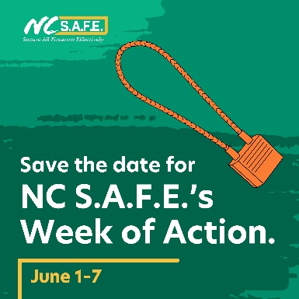
Join NC S.A.F.E.’s Week of Action, June 1–7, and take action to secure your firearm effectively.  All week long, @NorthCarolinaSAFE will share information and resources about safely storing firearms to help make your home and community safer. | Join NC S.A.F.E.’s Week of Action, June 1–7, and take action to secure your firearm effectively.  All week long, @nc_safe will share information and resources about safely storing firearms to help make your home and community safer.  #KeepNCSafe | Join NC S.A.F.E.’s Week of Action, June 1–7, and take action to secure your firearm effectively.  All week long, NC S.A.F.E. will share information and resources about safely storing firearms to help make your home and community safer. | Join NC S.A.F.E.’s Week of Action, June 1–7, and take action to secure your firearm effectively.  All week long, @nc_safe will share information and resources about safely storing firearms to help make your home and community safer.  #KeepNCSafe | You can find the full-size files for these graphics in the resource library of the website HERE.  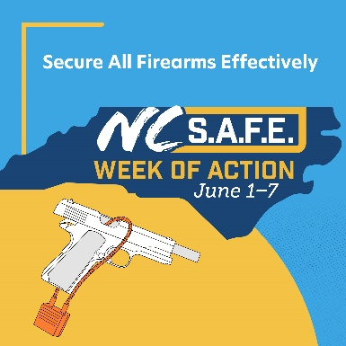
By keeping your firearms locked, unloaded, and out of reach, you’re preventing accidents and protecting your loved ones.  Follow @NorthCarolinaSAFE to learn ways to safely secure your guns: ncsafe.org | By keeping your firearms locked, unloaded, and out of reach, you’re preventing accidents and protecting your loved ones.  Follow @nc_safe to learn ways to safely secure your guns.  #KeepNCSafe | By keeping your firearms locked, unloaded, and out of reach, you’re preventing accidents and protecting your loved ones.  Learn about ways to safely secure your guns: ncsafe.org | By keeping your firearms locked, unloaded, and out of reach, you’re preventing accidents and protecting your loved ones.  Follow @nc_safe to learn ways to safely secure your guns: ncsafe.org  #KeepNCSafe | You can find the full-size files for these graphics in the resource library of the website HERE.  